

**FINAL REPORT OF TERM PROJECT**

**CMSE 201**

**Fundamentals of Software Engineering**

**Team members**

Abdulaziz Binafif 19701169

Hasan Oduncuoğlu 17330170

Boran Altuntaş 19331125

Ahmad Nedal Shahin 18700959

**GROUP NO : 01**

**PROJECT NAME : Canteen Automation System**

**PROJECT START DATE : 12/11/2020**

**PROJECT END DATE : 12/1/2021**

**SUPERVISOR : Assoc. Prof. Dr. Duygu Çelik Ertuğrul**

**SEMESTER TERM : Fall semester**

# ABSTRACT

The Project “Canteen Automation System” enables the end users to register online, read and select the food from e-menu card and order food online by just selecting the food that the user want to have using android application. The results after selecting the food from the E-menu card will directly appear on the screen near the Chef who is going to cook the food for you. The system is the combination of Android as well as Web Application. By using this application, the work of the waiter is reduced and we can also say that the work is nullified. The benefit of this is that if there is a rush in the Canteen then there will be chances that the waiters will be unavailable and the users can directly order the food to the chef online by using this application. The user will have a username and a password, by using which they can login into the system. This implies that the customer is the regular user of the Canteen. The manual system involves paperwork in the form of maintaining various files and manuals. Maintaining critical information in the files and manuals is full of risk and a tedious process. Including a framework showing how to apply Internet technology progressively as skills and confidence grow, the project demonstrates the route from adapting materials to developing an online environment. Nowadays people don’t have much time to spend in canteen by just there and waiting for the waiter to take their order. Many customers visit the canteen in their lunch break and recess so they have limited time to eat and return to their respective office and colleges. So, this software helps them to save time and order food whenever they want without calling the waiter again and again.

**Keywords:** Android, canteen, application, automation, food ordering, web application.

# Table of Contents

ABSTRACT II

Table of Contents III

LIST OF FIGURES V

LIST OF TABLES VI

1. INTRODUCTION 1

2. PROJECT PLANNING AND MANAGEMENT 2

2.1 Aim of Project: 2

2.2 Organization Scheme: 3

2.3 PERT analysis and network diagram: 5

2.4 List of Risks: 6

2.5 Intermediate CoCoMo 6

2.6 Gantt Chart WBS and Work Packages 4

2.6.1 List of Milestones.................................................................................... 12

2.6.2 Gantt Chart.............................................................................................. 4

2.6.3 Work Packages........................................................................................ 7

3. REQUIREMENTS ANALYSIS 13

3.1 Functional Requirements 13

3.2 Non-Functional Requirements 20

3.3 Realistic constraints 21

3.4 Ethical issues 22

4. DESIGN 23

4.1 High level design (architectural) 23

4.2 Low level design (architectural) 23

4.3 Software design 29

4.4 Interface design 35

4.5 Architectur design 36

5. IMPLEMENTATION 36

5.1 Tools, technologies and platforms used 36

5.2 Algorithms 37

5.3 Standards 37

5.4 Detailed description of the implementation (coding) 37

6. TESTING 37

7. USER GUIDE OF THE SYSTEM 37

8. DISCUSSION 39

9. CONCLUSION 39

10. REFERENCES 39

# LIST OF FIGURES

Organization Scheme

Network Diagram

Cocomo

Gantt Chart

Use Case Diagrams

Class Diagram

Activity Diagrams

Sequence Diagrams

Context Diagram

User Interfaces

# LIST OF TABLES

PERT analysis

List of Risks

List of Milestones

Work Packages

Instrument / Equipment / Software / RELEASE PURCHASES

Quarterly Estimated Cost Form (TL)

Functional Requirements and Use Case Descriptions

# 1. INTRODUCTION

# In today’s age of fast canteen automation in the canteen, many canteens have chosen to focus on quick preparation and speedy delivery of orders. Until very recently, all of this delivery of orders were placed over the phone, but there are many disadvantages to this system, including the inconvenience of the customer needing to have a physical copy of the menu, lack of a visual confirmation that the order was placed correctly, and the necessity for the canteen to have an employee answering the phone and taking orders. The main advantage of an online ordering system is that it greatly simplifies the ordering process for both the customer and the canteen. When the customer visits the ordering web page, they are presented with an interactive and up-to-date menu, complete with all available options and adjusting prices based on the selected options. After making a selection, the item is then added to their order, which the customer can review the details at any time before checking out. This provides instant visual confirmation of what was selected. This system also greatly lightens the load on the canteen’s end, as the entire process of taking orders is automated. Once an order is placed on the web page, it is entered into the database and then retrieved, in pretty much real-time, by a web-based application on the canteen’s end. Within this application, all items in the order are displayed, along with their corresponding options and delivery details, in a concise and easy to read manner. This allows canteen employees to quickly go through the orders as they are placed and produce the necessary items with minimal delay and confusion.

# 2. PROJECT PLANNING AND MANAGEMENT

First of all, “Canteen Automation System” is the system where customers order their food and receive food in the canteen without any delay as they can directly go and collect what they ordered without waiting for a turn or waiting time. This system aims to accelerate customer orders and customer order system used by employees to accept customer order. The purpose of the system is to develop a simple Canteen Automation System and implement it, which later will be used for a web-based application.

**The aim of the project** is to order food rapidly and to make it convenient for people who have limited time, and also to reduction the cost ,reduced paper work, and to computerized order and billing system.

**Product Scope:** The product is an online application that will allow its users to position orders from different firms for different kinds of food. This would have a simpler and quicker means of purchasing food. As consumers and managers will relate and transact very easily and without much effort, the commodity can improve the economy of most food sales canteens. There might also be an improvement in the rate of buying food from the canteens. So, in general this system greatly simplifies the ordering process for both the customer and the canteen, and also it reduced the cost and paper work.

**Organization Scheme:**

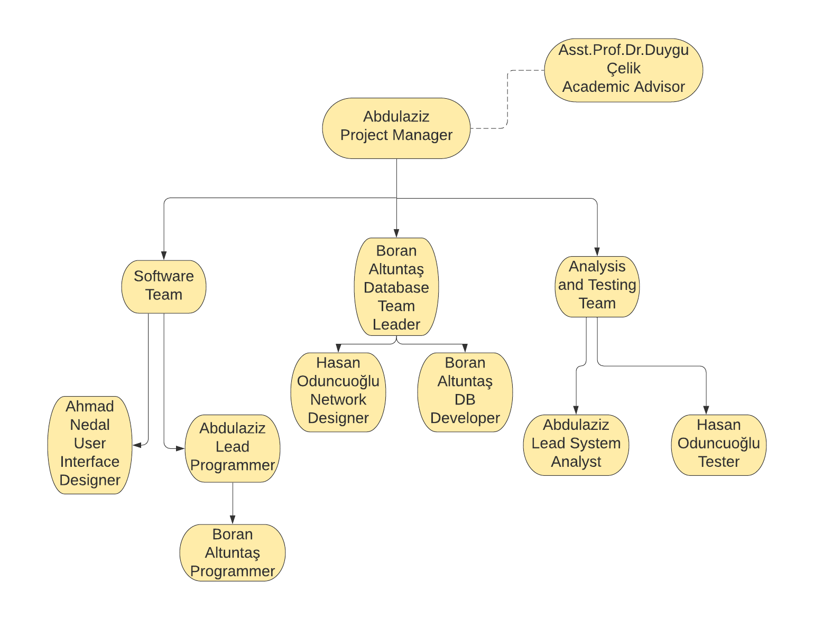

**Gantt Chart:**

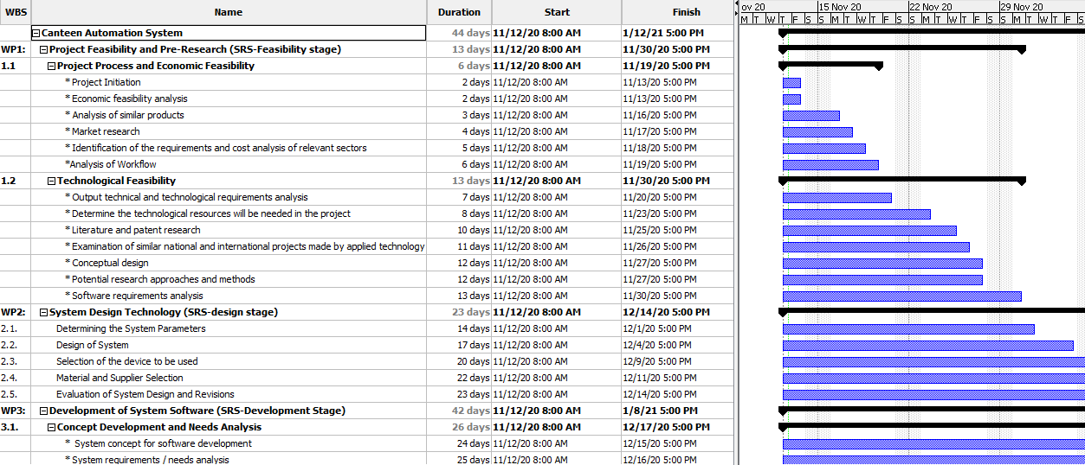

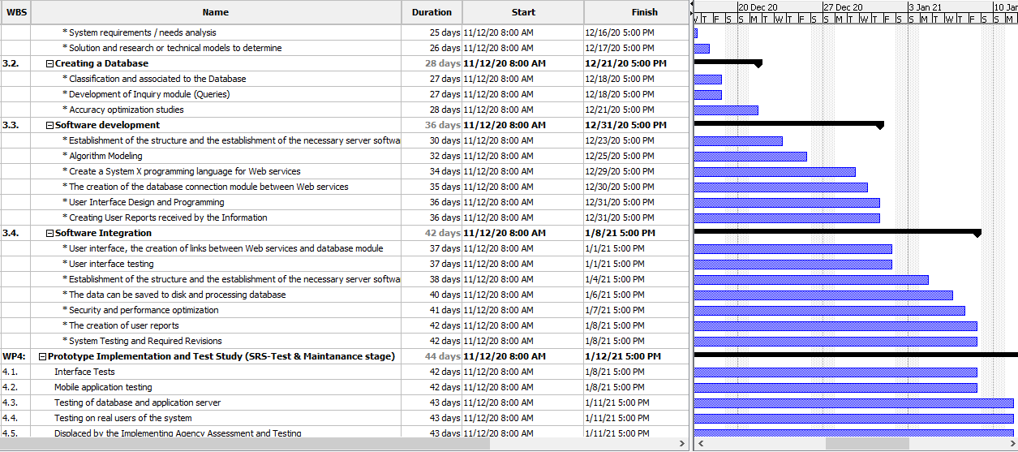

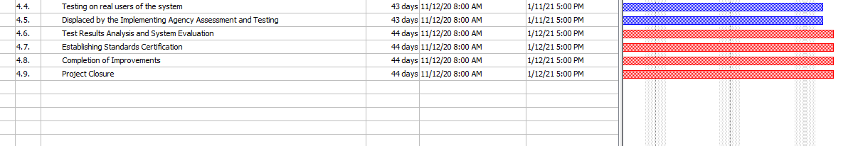

**PERT Analysis & Network diagram:**

|  |  |  |  |  |
| --- | --- | --- | --- | --- |
| **Work Package Name** | **Optimistic Time** | **Realistic Time** | **Pessimistic Time** | **Expected Time ((o+4r+p)/6)** |
| **Project Feasibility and Pre-Research (SRS-Feasibility stage)** | **9 days** | **12 days** | **21 days** | **13 Days** |
| **System Design Technology (SRS-design stage)** | **7 days** | **10 days** | **13 days** | **10 Days** |
| **Development of System Software (SRS-Development Stage)** | **14 days** | **19 days** | **22 days** | **18.67 Days** |
| **Prototype Implementation and Test Study (SRS-Test & Maintenance stage)** | **1 days** | **2** **days** | **3 days** | **2 Days** |

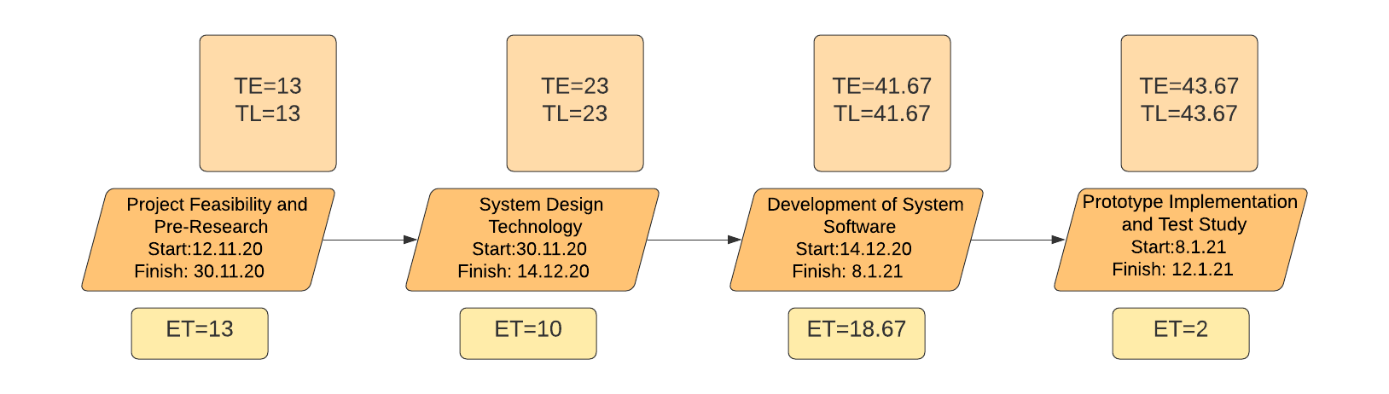

|  |  |  |
| --- | --- | --- |
| **Tasks** | **Predicates** | **Expected Time** |
| A | - | 6 |
| B | A | 7 |
| C | A | 10 |
| D | C | 3 |
| E | B, C | 2 |
| F | D, E | 8 |
| G | E | 6 |
| H | F | 2 |

|  |  |  |
| --- | --- | --- |
| **Paths** | **Calculations** | **Expected time for each path** |
| ABEFH | 6+7+2+8+2 | 25 |
| ABEG | 6+7+2+6 | 21 |
| ACEG | 6+10+2+6 | 24 |
| ACEFH | 6+10+2+8+2 | 28 |
| ACDFH | 6+10+3+8+2 | 29 |

**ACDFH is the critical path.**

**By using basic COCOMO in organic mode:**

**Our used language is SQL (21)**

**KLOC= (FP*loc)/1000**

**= (377*21)/1000 -> 7.917**

**Effort= 2.4*(7.917)^1.05 = 21.07**

**Duration= 2.5*(7.917)^0.38 = 5.49**

**Number of team members= Effort/Duration**

**= 21.07/5.49**

**=3.84 Person required**

**List of Risks:**

|  |  |  |  |
| --- | --- | --- | --- |
| Risk | Probability | Effects | Your Strategy |
| The time required to develop the software is underestimated. | High | Serious | With correctly configured work delivery and continuous team sessions, it is possible to resolve. |
| Software tools cannot work together in an integrated way. | High | Tolerable | New tools for manual use or combined uses can be found. |
| Customers fail to understand the impact of requirements changes. | Moderate | Tolerable | Changing demands with new understandable demands depends on requirements. |
| The rate of defect repair is underestimated. | Moderate | Tolerable | Replace potentially defective components with more reliable bought-in components. |
| The size of the software is underestimated. | High | Serious | Investigate buying sw components;  Investigate use of a program generator. |
| Code generated by code generation tools is inefficient. | Moderate | Insignificant | Code can be written in various languages, on different compilers. |
| Key staff are ill at critical times in the project. | Moderate | Serious | Reorganize team so that there is more overlap of work and people therefore understand each other’s jobs. |
| The database used in the system cannot process as many transactions per second as expected. | Moderate | Serious | Investigate the possibility of buying a higher-performance database. |

**List of work packages:**

|  |  |
| --- | --- |
| **Work Package No** | 1 |
| **Work Package Name** | **Project Feasibility and Pre-Research (Feasibility Analysis)** |
| **Start-End Date and Time** | 12/11/2020 – 30/11/2020 (2 Weeks) |
| **Related Organizations** | - |

|  |
| --- |
| **1- List the activities of work packages.** |
| **1.1 Project Process and Economic Feasibility:**  **\* Project Initiation**  **\* Economic feasibility analysis**  **\* Analysis of similar products**  **\* Market research**  **\* Identification of the requirements and cost analysis of relevant sectors**  **\*Analysis of Workflow**  **1.2 Technological Feasibility:**  **\* Output technical and technological requirements analysis**  **\* Determine the technological resources will be needed in the project**  **\* Literature and patent research**  **\* Examination of similar national and international projects made by applied technology**  **\* Conceptual design**  **\* Potential research approaches and methods**  **\* Software requirements analysis** |
| **2- Describe the methods and parameters that will be used for work package.** |
| In this work package, technical, legal, operational and schedule feasibility strategies will be used. |
| **3- List the experiments, tests and analysis in the work package.** |
| * Economic market and outcomes test * Technological requirements and users’ need test * Project process flow test |
| **4- List the output of work package and its success criterias.** |
| **Outputs:**  The output of feasibility study is to show similar projects’ market space and missing features.  **Success Criterias:**  If current system has little usability and features, our project will deserves working on it. |
| **5- Explain the relation of output with other work packages** |
| Other work packages are needed for this feasibility work package, so we can only start working on other work packages after this work package is successfully completed. |

|  |  |
| --- | --- |
| **Work Package No** | 2 |
| **Work Package Name** | **Based System Design Technology (Analysis & Design stage)** |
| **Start-End Date and Time** | 30/11/2020 – 14/12/2020 (10 days) |
| **Related Organizations** | - |

|  |
| --- |
| **1- List the activities of work packages.** |
| * **Determining the System Parameters** * **Design of System** * **Selection of the device to be used** * **Material and Supplier Selection** * **Evaluation of System Design and Revisions** |
| **2- Describe the methods and parameters that will be used for work package.** |
| * Figuring out system architecture with this work package * Research about the most useful methodologies that suit the project |
| **3- List the experiments, tests and analysis in the work package.** |
| * Research about convenient development interface * Research about coding language * Research about application of system architecture to the project |
| **4- List the output of work package and its success criterias.** |
| **Outputs:**  The most important output is fully ready system architecture for development stage.  **Success Criterias:**  Convenient models and methodologies. |
| **5- Explain the relation of output with other work packages** |
| Before starting development and implementation steps, the most important thing is that system design/architecture reach success at next steps of the project. |

|  |  |
| --- | --- |
| **Work Package No** | 3 |
| **Work Package Name** | **Development of System Software (SRS-Development Stage)** |
| **Start-End Date and Time** | 14/12/2020 - 8/1/2021 (19 days) |
| **Related Organizations** | - |

|  |
| --- |
| **1- List the activities of work packages.** |
| * + - **Concept Development and Needs Analysis**     - **Creating a Database**     - **Software development**     - **Software Integration** |
| **2- Describe the methods and parameters that will be used for work package.** |
| * Creating relational database with ER and different types of diagrams * Using pre-desired software language and platform |
| **3- List the experiments, tests and analysis in the work package.** |
| * Start time for coding * Little unit tests for strong codes * Integration with IDE, DB * Interface design with professional tools |
| **4- List the output of work package and its success criterias.** |
| **Outputs:**   * Running sample application of the project * Ready to test the codes   **Success Criterias:**  Low error rate in coding step.  Effective database design and implementation. |
| **5- Explain the relation of output with other work packages** |
| As other work packages are preparatory for this phase, the project is completely linked to this work package. Only testing and releasing steps will occur after this work package. |

|  |  |
| --- | --- |
| **Work Package No** | 4 |
| **Work Package Name** | **Prototype Implementation and Test Study and Maintenance (SRS-Test &Maintenance stage)** |
| **Start-End Date and Time** | 8/1/2021 – 12/1/2021 |
| **Related Organizations** | - |

|  |
| --- |
| **1- List the activities of work packages.** |
| * **Interface Tests** * **Mobile application testing** * **Testing of database and application server** * **Testing on real users of the system** * **Displaced by the Implementing Agency Assessment and Testing** * **Test Results Analysis and System Evaluation** * **Establishing Standards Certification** * **Completion of Improvements** * **Project Closure** |
| **2- Describe the methods and parameters that will be used for work package.** |
| * Database testing * Interface testing by all team members * Testing real users’ opinions about the project and usability |
| **3- List the experiments, tests and analysis in the work package.** |
| Unit test will be completed and correcting errors if there exist, unit test is the most important test for project release step. |
| **4- List the output of work package and its success criterias.** |
| **Outputs:**   * Reporting test results. * Ready to release the project.   **Success Criterias:**  The application should be passed from all tests perfectly. |
| **5- Explain the relation of output with other work packages** |
| This work package is the last one. So, if this work package’s steps will be perfectly completed, our project will be done. It means the project is ready to release market and gain. |

**List of Milestones:**

|  |  |  |
| --- | --- | --- |
|  | **Description of Output** | **Expected Time Interval** |
| 1 | Project Feasibility and Pre-Research (SRS-Feasibility stage) | 12/11/2020 - 30/11/2020 |
| 2 | System Design Technology (SRS-design stage) | 30/11/2020 – 14/12/2020 |
| 3 | Development of System Software (SRS-Development Stage) | 14/12/2020 – 8/1/2021 |
| 4 | Prototype Implementation and Test Study (SRS-Test & Maintenance stage) | 8/1/2021 – 12/1/2021 |

**Instrument / Equipment / Software / RELEASE PURCHASES**

|  |  |  |  |  |  |  |  |  |  |  |  |  |  |
| --- | --- | --- | --- | --- | --- | --- | --- | --- | --- | --- | --- | --- | --- |
| **Project Name** | | **Canteen Automation System** | | | | | | | | | | | |
| **Line no** | **Instrument / Equipment / Software / Publication Name** | | **No. of Item** | | **Capacity** | **Technical specification** | | **Purpose of Project Activities** | **Post-Project Place of Use / Purpose** | | **Unit Price (USD)** | **Unit Price (TL)** | **Total Amount (TL)** |
| **R & D** | **Production** |
| **1** | Laptop | | 1 | |  | Min, i3 - 1gb | | Coding | Coding | Coding | 800 $ | 6100 TL | 6100TL |
| **2** | Internet Connection | | 1 | |  |  | | Connection | Research/ testing | Communication | 55 $ | 420 TL | 420 TL |
| **3** | Android Device | | 1 | |  | Min, Android 4 | | Emulation | Emulation | Test | 80 $ | 610 TL | 610 TL |
| **4** | Printer | | 1 | |  | HP | | Printing out | Documentation | Documentation | 100 $ | 765 TL | 765 TL |
|  | 1035 $  **TOTAL** | | | 7895 **TL** | | |

**Quarterly Estimated Cost Form (TL)**

|  |  |  |  |  |
| --- | --- | --- | --- | --- |
| **Project Name: Canteen Automation System** | | | | |
| **Cost Item** | **2019-2020** | | **TOTAL**  **(TL)** | **TOTAL COST RATE OF CONTENTS (%)** |
| **I** | **II** |
| **Personnel** | 50.000 | 50.000 | 100.000 | 89,48% |
| **Travel** | 2.500 | 2.500 | 5.000 | 1,52% |
| **Instrument / Equipment / Software / Publications** | 10.000 |  | 10.000 | 9% |
| **Domestic Works Made By R & D and Testing Institutions** |  |  |  |  |
| **International Works Made By R & D and Testing Institutions** |  |  |  |  |
| **Domestic Services Procurement** |  |  |  |  |
| **Overseas Service Procurement** |  |  |  |  |
| **Material** |  |  |  |  |
| **TOTAL COST** | 62.500 | 52.500 |  | 100 |
| **CUMULATIVE COST** |  |  | 115.000 | 100 |
| **IN THE PROJECT TOTAL MAN-MONTH** | | | 115.000 | |

# 3. REQUIREMENTS ANALYSIS

## 3.1 Functional Requirements

REQ1: The system should enable Customers to register.

REQ2: The system should enable Customers to login.

REQ3: The system should enable Customers to logout.

REQ4: The system should enable Customers to change a forgotten password

REQ5: The system should enable customers to edit their profile.

REQ6: The system should enable customers to view their profile.

REQ7: The system should enable Customers to view Canteen that deliver to their location.

REQ8: The system should enable Customers to view a canteen.

REQ9: The system should enable Customers to search for menu item

REQ10: The system should enable Customers to view a menu item

REQ11: The system should enable Customers to view cart

REQ12: The system should enable Customers to add menu items to cart

REQ13: The system should enable Customers to remove menu items from cart

REQ14: The system should enable Customers to checkout / View order summary

REQ15: The system should enable Customers to add addresses

REQ16: The system should enable Customers to Send Order

REQ17: The system should enable Customers to Receive order confirmation

REQ18: The system should enable Customers to search Restaurant names

REQ19: The system should enable Customers to set confirmation wait time

REQ20: The system should enable Customers to add restaurant and orders to favorites

REQ21: The system should enable Customers to view favorites

REQ22: The system should enable Customers to remove restaurant from favorites

REQ23: The system should enable Customers to view order history

REQ24: The system should enable Canteen Administrations to register.

REQ25: The system should enable Canteen Administrations to login.

REQ26: The system should enable Canteen Administrations to edit Canteen info

REQ27: The system should enable Canteen Administrations to build menu

REQ28: The system should enable Canteen Administrations to view menu

REQ29: The system should enable Canteen Administrations to View Orders

REQ30: The system should enable Canteen Administrations to delete orders

REQ31: The system should enable Canteen Administrations to Select/Open Orders

REQ32: The system should enable Canteen Administrations to Accept/Reject Orders

**3.2 Actor - Customer**

*3.2.1 Description and Priority*

The customer is the user that carries out the ordering process. He/ She orders food from the canteen.

The following are features of the system associated with the customer. They describe how the customer interacts with the system.

*3.2.2 Detailed User Requirements*

REQ1: The system should enable Customers to register.

* Collect user information (Name, Email, Password)
* Check if information is valid
* Password not empty
* Password and Password confirm the same
* Email has not been used before and right Email format.
* If information is valid, save and add user to database
* Send confirmation message to user’s email.
* When user clicks confirmation link, authorize user access.

REQ2: The system should enable Customers to login.

* They shall enter their email and password.
* The information given shall be valid.
* Access shall be granted/denied.

REQ3: The system should enable Customers to logout.

* Log user out when user selects the logout button.

REQ4: The system should enable Customers to change a forgotten password

* Collect user email
* Send change password message to user’s email
* Collect user’s new password
* Save and edit user’s password in database.

REQ5: The system should enable customers to edit their profile.

* User shall be allowed to edit old information by entering new information
* This information shall replace the old one in the database

REQ6: The system should enable customers to view their profile.

* The system shall show users their information as saved in the database.

REQ7: The system should enable Customers to view Restaurants that deliver to their location.

* The system shall use the user’s address to display a page containing restaurants that deliver to the user’s address.
* The system shall display both restaurants that are open and closed for delivery, differentiating between closed and open with a color code.

REQ8: The system should enable Customers to view a restaurant.

* The system shall display the restaurant’s menu

REQ9: The system should enable Customers to search for menu item

* The Customer should be able to enter the name of the menu item to be searched for
* The system displays all menu items that fit the Customer’s search criteria.

REQ10: The system should enable Customers to view a menu item

* The system shall display the details of the selected menu item (Name, Picture, Description, Price)
* The system shall display the option to add the displayed menu item to cart

REQ11: The system should enable Customers to view cart

* The system shall display menu items the user has added to cart from various catagories.
* The system shall display the selected quantity of each item.
* The system shall display individual and total prices of all displayed cart items
* REQ12: The system should enable Customers to add menu items to cart
* The system shall allow customers to long press to add a menu item to cart.
* The system shall also allow customers to add menu item to cart by clicking a button when the customer views the menu, item’s details.

REQ13: The system should enable Customers to remove menu items from cart

* The system shall display the option of deleting a menu item from the cart.

REQ14: The system should enable Customers to checkout / View order summary

* The system shall display all cart items (Name, Short Description, and Price) and allow the user to remove the item.
* The system shall display the total price of all the selected items
* The system shall give the user the option of selecting whether to pay with cash or card.
* The system shall allow the user to select delivery address from saved address list.
* The system shall allow the user to add a delivery address to the address list.
* The system shall allow the customer to reduce or increase quantity of a menu item.
* The system shall display a button that enables user to confirm and send the order to the restaurant.

REQ15: The system should enable Customers to add Addresses

* When editing profile and during checkout, the system shall give the user the option of adding an address to the users address list.

REQ16: The system should enable Customers to Send Order

* The customer should click the button on the checkout page that enables the user to send order.
* The system shall send the order to the respective restaurants the user has selected

items from.

REQ17: The system should enable Customers to Receive order confirmation

* The system shall display an ‘order accepted’ message if the restaurant accepts the user’s order
* The system shall display an ‘order rejected message’ if the restaurant rejects the user’s order. The reason for rejection shall accompany the rejection message.
* If a time of X minutes (minutes saved on the user profile for wait time) runs out since the customer sent the order and the restaurant has not accepted or rejected the order, the system displays an order rejected message with reason – ‘time ran out’. Giving the user the option to resend the order.

REQ18: The system should enable Customers to search Restaurant names

* The Customer should be able to enter the name of the restaurant to be searched for
* The system displays all restaurants in the customer’s general location that fit the Customer’s search criteria.

REQ19: The system should enable Customers to set confirmation wait time

* The customer shall input the desired wait time before order is rejected by default due to time running out.
* The system shall allow restaurants to accept or reject the customer’s order in this

period. After which a default reject message is sent to the customer with reason – ‘time ran

out’. Giving the user the option to resend the order.

REQ20: The system should enable Customers to add restaurant and orders to favorites

REQ21: The system should enable Customers to view favorites

REQ22: The system should enable Customers to remove restaurant from favorites

REQ23: The system should enable Customers to view order history.

**3.3 Actor – Administrator**

*3.3.1 Description and Priority*

The managers need to be able to provide an account so that they can navigate their restaurant's system. This is vital because it guarantees security because a password is provided.

The following are features of the system associated with the administrator. They describe how the canteen interacts with the system.

*3.3.2 Detailed User Requirements*

REQ24: The system should enable Administrators to register.

* The system collects Administrators information (Restaurant name, Email, Password)
* Check if information is valid

Password not empty

* Password and Password confirm the same
* Email has not been used before and right Email format.
* If information is valid, save and add restaurant to database
* Send confirmation message to restaurant’s email.
* Send a special access code to the restaurant’s email.
* When restaurant clicks confirmation link, prompt for the access code.
* If access code is authorized, grant the restaurant access.

REQ25: The system should enable Restaurants to login.

* They shall enter their email, access code and password.
* The information given shall be valid.
* Access shall be granted/denied.

REQ26: The system should enable Administrators to edit Canteen info

* On first login, the system displays this page to fill restaurant info.
* The system shall allow the Administrators to fill in contact info (Phone number, Address, State, Region, Country)
* The system shall allow the Administrators to pick delivery regions.
* The system shall allow the Administrators to set delivery time
* The system shall allow the Administrators to upload logo

REQ27: The system should enable Administrators to build menu

* The system shall allow the Administrators to input menu item (name, description, price, picture)
* The system shall allow the Administrators to add optional menu items (name, picture, price)

REQ28: The system should enable Administrators to view menu

* The system shall display the saved canteen menu as it will be displayed to the customers.

REQ29: The system should enable Administrators to View Orders

* The system shall display all current orders becoming less opaque (disappearing) as the

time for the order confirmation runs out.

REQ30: The system should enable Administrators to delete orders

* The system shall display accepted or rejected offers with a delete button
* The system shall delete orders every hour regardless of whether the administrators deletes it or not

REQ31: The system should enable Administrators to Select/Open Orders

* The system shall display a page with order details (Items, Optional Ingredients, Order

address, Price, Customer telephone number, etc.)

REQ32: The system should enable Administrators to Accept/Reject Orders

* The system shall display all current orders with an accept or reject button

**3.4 Use case Diagram**

*3.4.1 Customer*

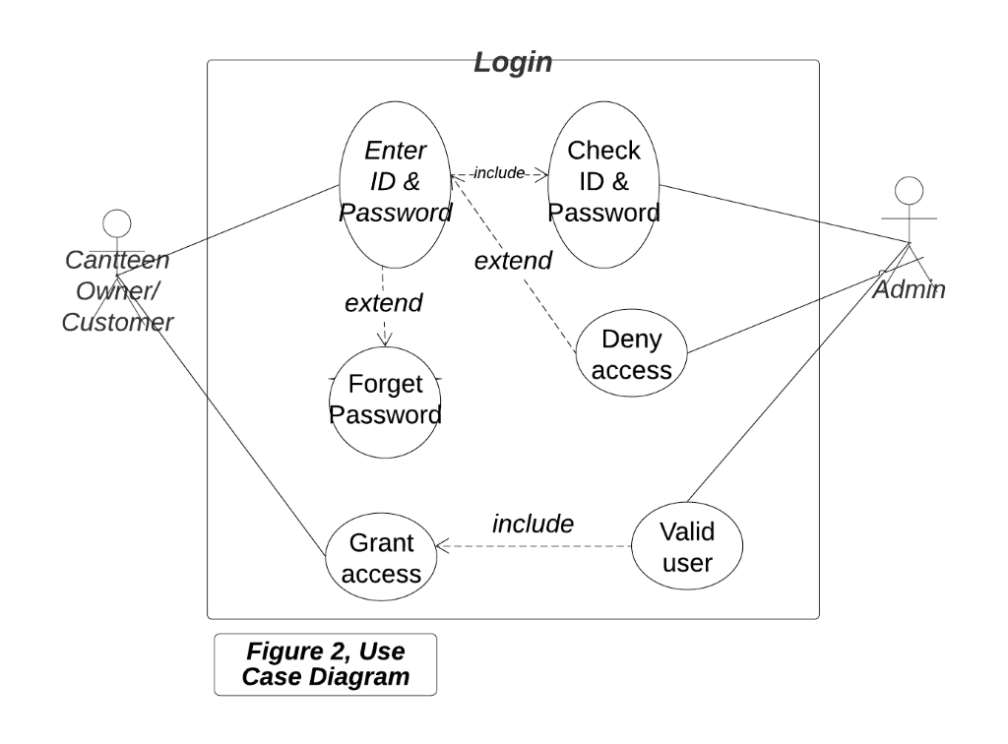

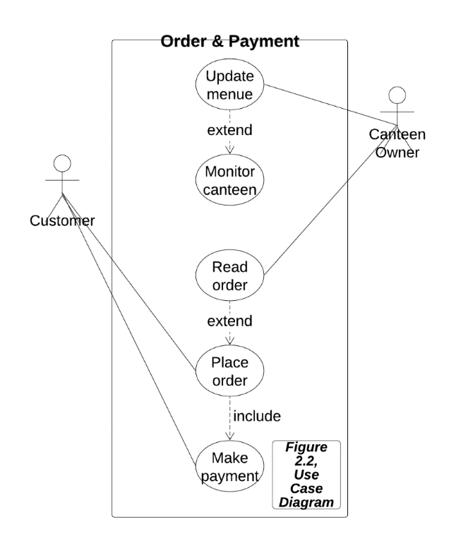

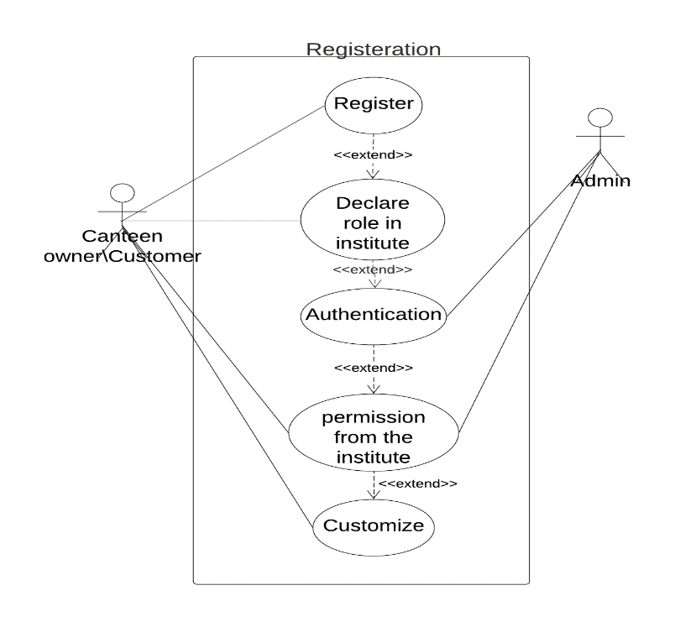figure 2.3

*3.4.2 Administrator*

Figure 2.4

## 3.5 Non-Functional Requirements

*3.5.1 Reliability*

* The system should be available when requested for service by users: The system should work 24/7, it should always be up and running so that whenever the user wants to use it, it is available.
* The system should have a very low failure rate: The failure rate should be kept as minimal as possible, preferably less than 0.01.

*3.5.2 Performance*

* The system must have a good response time.
* The load time for the user interface should take less than two seconds.
* The log in information should be verified within five seconds.
* Queries shall return results within five seconds.
* The system should be able to achieve a lot in a specified amount of time.
* The system should be able to withstand a heavy workload.
* It should be able to respond to multiple numbers of people at the same time.
* The system must run error free while operating with a huge set of data.
* The system should be precise and accurate when dealing with data.
* The system’s error rate should be minimal

*3.5.3 Security*

* All external communications between the system’s data server and clients must be encrypted
* To ensure that the system is secure access to the various subsystems will be protected by a user log in screen and requires a user name and password.
* The System admin shall provide an access code to restaurants upon registration after successful verification of their restaurant.
* All system data must be backed up every 24 hours and the backup copies stored in a secure location, which is not in the same building as the system: This is done to avoid loss of information in case of system crash. The system data should be stored in storage device e.g., hard drive, CD, Flash drive or it could be stored in files.

*3.5.4 Usability*

* The system should include a questions page for users to ask questions or complaints about the application
* The system should have a frequently answered questions page to tackle major
* The system should have a well formed, easy to use graphical user interface
* The system should be user friendly
* The system must be easy to learn for both novices and users with experience from similar systems
* The system must be efficient for the frequent use
* The system must be easy to remember for the casual user
* The user must understand what the system does
* The user must feel satisfied with the system

*3.5.5 Safety*

* The system should maintain a good backup: Maintaining backups ensures that the system’s database is secure, which means that in case of an emergency or accident the system can be easily restored.

*3.5.6 Maintainability*

* The system should be easy to maintain.
* In order for the system to be easy to maintain, it is done with an object-oriented language, which is easy to maintain.
* Maintenance of the system should be cost efficient
* Maintenance of the system should be less frequent
* The system should easily adapt to changes made
* The system should be able to detect the location of the user

## 3.6 Realistic constraints

1. The project is economically Feasible; it was proven to be of ample benefits to the

Northern Cyprus economy and the economy in general:

* It reduces ordering time and costs.
* It increases the general revenue of the food sector.

2. The project is environmentally safe:

* Producing or using it doesn`t consume a lot of power. It only requires a sufficiently charged system.
* Using the system doesn`t leads to pollution of the environment due to the fact that the system is used in the confinements of people`s houses or offices.

3. The project is socially Feasible:

* It has made the food ordering procedure better and more convenient.
* It will encourage more customers to order food.
* It can be used by people of all ages provided they are computer literate.

4. There are no political constraints therefore it is politically feasible.

5. There are no ethical constraints: The codes were self-written so there are no copyright infringements.

6. Health and safety: Using this product is very safe and it doesn`t endanger the health and safety of people or society. It helps reduce the risk of allergic reactions since the customer can be more specific with the order at no risk of mistake.

7. Manufacturability: The system can be manufactured using reasonable amount of available resources.

8. Sustainability: The product be used over the long term provided that it is properly maintained.

## 3.7 Ethical issues

There are no major ethical issues with using this system as all canteens will be officially licensed and undergo a verification process before they are given an access code for system use.4. DESIGN

## 4.1 High level design (architectural)

Below is a context diagram showing the system and its main modules, including the relationship between them. The context diagram displays the system's most basic functions. The customer and the administration are external organizations that deal with the system. The customer places an order, which is sent by the system to the canteen. By either approving the order or refusing it, the administration reacts. The device sends this response to the customer.

Figure 4.1 Context Diagram

Canteen Administrator

Canteen Automation System

Send order info

Order

Customer

Accept/Reject Order

Response

**4.2 Low level design (components used)**

*4.2.1 Use Cases*

**Overall system written use case tables are given below:**

**Table 4.1 Register Detailed Use Case**

|  |  |
| --- | --- |
| **Use Case - 1** | Register |
| **Actor** | Admin, Customer |
| **Goal** | To create an account |
| **Preconditions** | The system displays the register page |
| **Stimulus** | The user wishes to create a new account |
| **Scenario** | 1) The user selects ‘Register’ from the homepage menu  2) The system prompts the user for information (Name, Email, Password, Confirm Password)  3)The user fills in the data fields  4) The system analyzes the user’s data for validity  5) A security confirmation link is sent to the user’s email  6) The user confirms their identity by clicking on the link |
| **Exceptions** | Invalid information is inputted by the user |

**Table 4.2 Login Detailed Use Case**

|  |  |
| --- | --- |
| **Use Case - 2** | Login |
| **Actor** | Admin, Customer |
| **Goal** | Enable user access to the system |
| **Stimulus** | The user requests access to the system |
| **Preconditions** | 1) The user already has a valid username and password  2) The user is not already logged in |
| **Scenario** | 1) The user selects ‘login’ from the menu  2) The system prompts the user for their username and password  3) The user enters their username and password  4) The system grants access to the user |
| **Exceptions** | The user enters invalid username or password |

**Table 4.3 Logout Detailed Use Case**

|  |  |
| --- | --- |
| **Use Case - 3** | Logout |
| **Actor** | Admin, customer |
| **Goal** | Disable user access to the system |
| **Preconditions** | The user is already logged in |
| **Stimulus** | The user no longer requires access to the system |
| **Scenario** | 1) The user selects ‘logout’ from the menu  2) The system disables access |
| **Exceptions** |  |

**Table 4.4 Add menu item Detailed Use Case**

|  |  |
| --- | --- |
| **Use Case - 4** | Add menu item |
| **Actor** | Admin |
| **Goal** | The restaurant wants to add an item to their menu |
| **Preconditions** | The user is already logged in |
| **Stimulus** | The restaurant requests more items on their menu |
| **Scenario** | 1)The user clicks on ‘menu’ from the main menu  2) The system opens the current available items on the menu  3) The user selects ‘edit menu’  4) The system enables the editing features on the menu  5) The user selects ‘add item’  6) The system enables more editing features  7) The user clicks finish when done  8) The system displays new changes made by the user |
| **Exceptions** |  |

**Table 4.5 Delete menu item Detailed Use Case**

|  |  |
| --- | --- |
| **Use Case - 5** | Delete menu item |
| **Actor** | Admin |
| **Goal** | The restaurant wants to remove an item from their menu |
| **Preconditions** | The user is already logged in |
| **Stimulus** | The restaurant wishes to delete an item off their menu |
| **Scenario** | 1)The user clicks on ‘menu’ from the main menu  2) The system opens the current available items on the menu  3) The user selects ‘edit menu’  4) The system enables the editing features on the menu  5) The user selects ‘delete item’  6) The system asks for confirmation: ‘Do you wish to delete this item?’  7) The user clicks ‘yes’ |
| **Exceptions** |  |

|  |  |
| --- | --- |
| **Use Case - 6** | Accept Order |
| **Actor** | Admin |
| **Goal** | The restaurant chooses to accept a customer’s order |
| **Preconditions** | A customer has already placed an order |
| **Stimulus** | The restaurant wants to serve the customer |
| **Scenario** | 1)The user selects ‘Manage Orders’ from the table menu  2) The system displays more subcategories  3) The user selects ‘View current orders’  4) The system displays the current pending orders of customers  5) The user clicks on a customer’s name  6) The system displays the details of the customer’s orders  7) The user clicks ‘Accept Order’ |
| **Exceptions** |  |

**Table 4.7 Reject Order Detailed Use Case**

|  |  |
| --- | --- |
| **Use Case - 7** | Reject Order |
| **Actor** | Admin |
| **Goal** | The restaurant chooses to reject a customer’s order |
| **Preconditions** | A customer has already placed an order |
| **Stimulus** | The restaurant does not wish to serve the customer |
| **Scenario** | 1)The user selects ‘Manage Orders’ from the table menu  2) The system displays more subcategories  3) The user selects ‘View current orders’  4) The system displays the current pending orders of customers  5) The user clicks on a customer’s name  6) The system displays the details of the customer’s orders  7) The user clicks ‘Reject Order’ |
| **Exceptions** |  |

**Table 4.8 Credit Card Payment Detailed Use Case**

|  |  |
| --- | --- |
| **Use Case - 8** | Process Credit Card Payment |
| **Actor** | Admin |
| **Goal** | Charge a customer for their meal using a credit card |
| **Preconditions** | A meal has been assigned to the customer’s credit card payment bill |
| **Stimulus** | The restaurant wants to finalize a customer’s bill |
| **Scenario** | 1)The user selects ‘Bill Table’ from the main menu  2) The user selects ‘Pending Payment’  3) The user selects a customer’s name to process payment for from a list of customers with meals assigned to their credit card payment bill  4) The user swipes the customer’s bankcard through a POS device  5) The system interfaces with the register system to process the payment  6) The customer’s name disappears from the ‘Pending Payment’ list |
| **Exceptions** | The transaction is rejected by the register system |

**Table 4.9 Cash Payment Detailed Use Case**

|  |  |
| --- | --- |
| **Use Case - 9** | Process Cash Payment |
| **Actor** | Admin |
| **Goal** | Charge a customer for their meal using a cash |
| **Preconditions** | A meal has been assigned to the customer’s credit card payment bill |
| **Stimulus** | The restaurant wants to finalize a customer’s bill |
| **Scenario** | 1)The user selects ‘Bill Table’ from the main menu  2) The user selects ‘Pending Payment’  3) The user selects a customer’s name to process payment for from a list of customers with meals assigned to their cash payment bill  4) The user collects cash from the customer  5) The user processes payment through the payment system  6) The customer’s name disappears from the ‘Pending Payment’ list |
| **Exceptions** | Insufficient cash is provided by the customers |

**Table 4.10 View menu Detailed Use Case**

|  |  |
| --- | --- |
| **Use Case – 10** | View Menu |
| **Actor** | Customer |
| **Goal** | To view items on the menu |
| **Preconditions** | User must be logged in |
| **Stimulus** | The customer wishes to see what is available on the menu |
| **Scenario** | 1) The customer clicks ‘View Menu’ from the main menu  2) All the items on the menu are displayed |
| **Exceptions** | An item is deactivated by user preferences |

**Table 4.11 Search menu Detailed Use Case**

|  |  |
| --- | --- |
| **Use Case - 11** | Search Menu |
| **Actor** | Customer |
| **Goal** | To view a specific item on the menu |
| **Preconditions** | Customer must be logged in |
| **Stimulus** | The user must be logged in |
| **Scenario** | 1)The customer selects ‘View Menu’ from the main menu  2) The customer clicks on the search field  3) The customer types in the name of an item  4) The system displays result |
| **Exceptions** | The item is unavailable on the menu |

**Table 4.12 Place order Detailed Use Case**

|  |  |
| --- | --- |
| **Use Case - 12** | Place Order |
| **Actor** | Customer |
| **Goal** | Place an order for menu items from the restaurant |
| **Preconditions** | The customer is logged in |
| **Stimulus** | The customer wants to order one or more menu items |
| **Scenario** | 1) The customer selects ‘View Menu’ from the main menu  2)The customer selects ‘Select’  3)The customer taps on any items they wish to have  4)The customer selects ‘Finish’  5) The system displays a menu of options  6) The customer selects ‘Place Order’  7) The admin is notified of the customer’s order |
| **Exceptions** | The customer cancels the order by selecting ‘Cancel’ |

**Table 4.13 Pay bill Detailed Use Case**

|  |  |
| --- | --- |
| **Use Case - 13** | Pay Bill |
| **Actor** | Customer |
| **Goal** | A customer wants to pay their bill |
| **Preconditions** | An order has been placed |
| **Stimulus** | A customer wants to finalize their order |
| **Scenario** | 1) The customer has selected items they wish to order  2) The customer selects their payment method  3) The customer finalizes the process and an alert is sent to the admin  4)The admin processes the payment |
| **Exceptions** | The customer cancels the process |

**Table 4.14 Indicate item ready Detailed Use Case**

|  |  |
| --- | --- |
| **Use Case - 14** | Indicate item ready |
| **Actor** | Admin |
| **Goal** | To notify the customer that their order has been prepared and is being delivered |
| **Preconditions** | The order was accepted |
| **Stimulus** | Order preparation is complete |
| **Scenario** | 1) The user selects a customer’s name from a list of pending orders  2) The user selects ‘Ready’  3) An alert is sent to the customer to notify them |
| **Exceptions** | None |

**Table 4.15 Track delivery Detailed Use Case**

|  |  |
| --- | --- |
| **Use Case - 15** | Track Delivery |
| **Actor** | Customer |
| **Goal** | To view the progress of customer’s order |
| **Preconditions** | Order has been placed and order is ready |
| **Stimulus** | The order is being delivered |
| **Scenario** | 1)The user selects ‘Track Delivery’ from the main menu  2) The system displays the location of the delivery driver |
| **Exceptions** | None |

**Table 4.16 Customer service Detailed Use Case**

|  |  |
| --- | --- |
| **Use Case - 16** | Seek Customer Service |
| **Actor** | Customer |
| **Goal** | To seek for help from the admin |
| **Preconditions** | None |
| **Stimulus** | The customer is having trouble with the system |
| **Scenario** | 1)The user selects ‘Customer Services’ from the main menu  2) The user selects what kind of help they need  3) The user writes their queries and selects ‘Send’  4) The message is sent to the admin with an alert to notify them |
| **Exceptions** | None |

## 4.3 Software design

figure 4.3.1 about take out

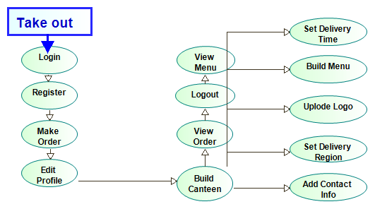

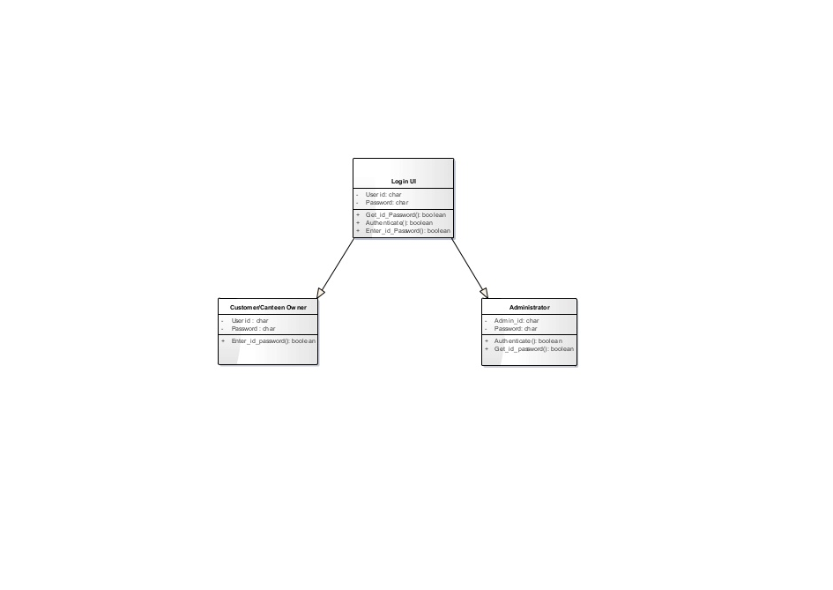figure 4.3.2 class diagram for login

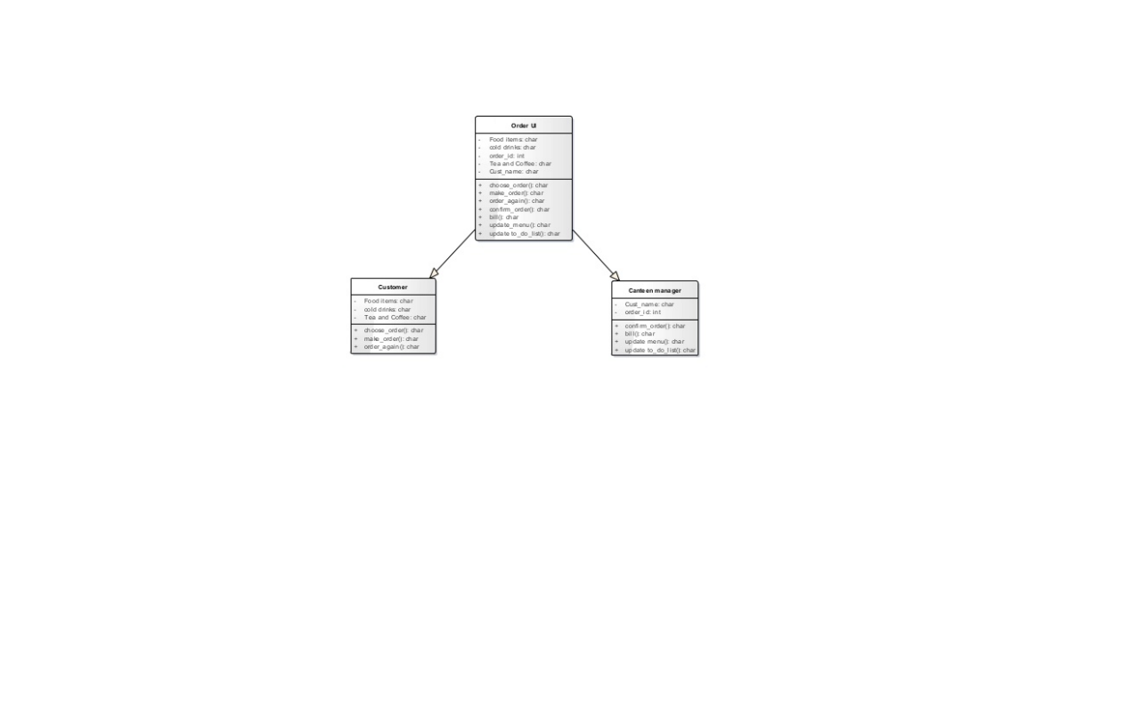

figure 4.3.3 class diagram for order & update

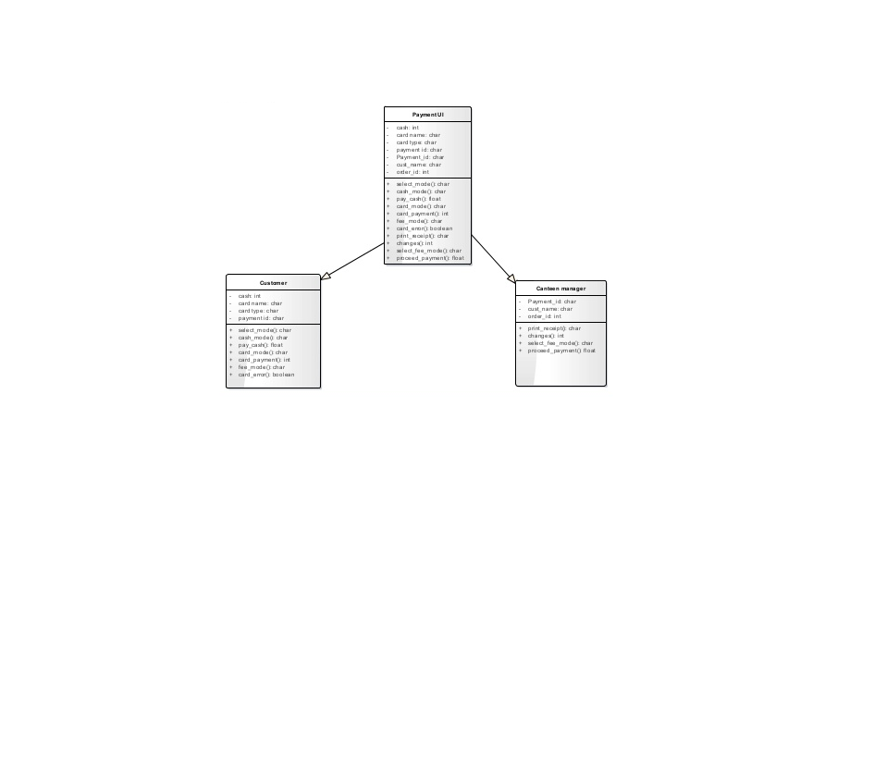 figure 4.3.4 class diagram for payment

Figure 4.3.5 activity diagram for place order

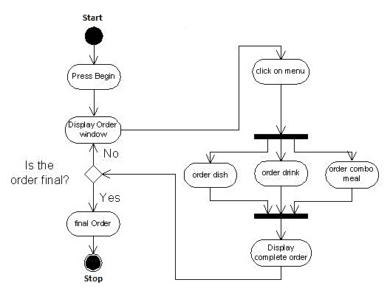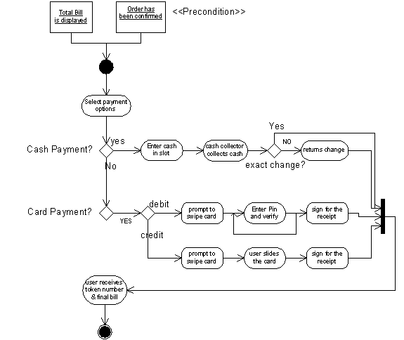

figure 4.3.6 activity diagram for payment

figure 4.3.7 activity diagram for monitor the inventory

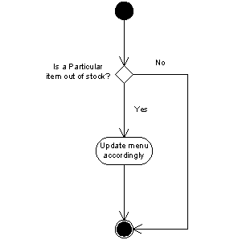

figure 4.3.8 activity diagram for update the menu

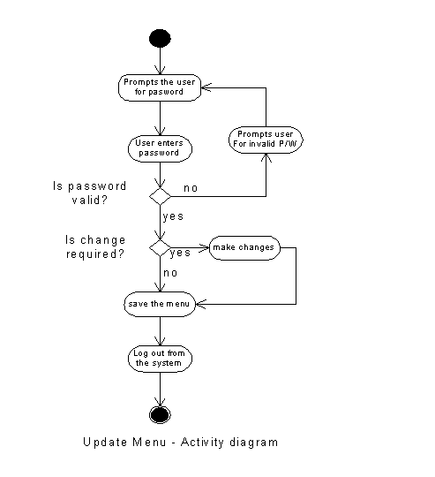

Figure 4.3.9 sequence diagram for registration

Page | 26
Fig. 3.2 Sequence Diagram for Registration
sd Use Case Model
Canteen Owner/Customer
REGISTRATION
UI
LOGIN UI
Get...

Figure 4.3.10 sequence diagram for payment

Page | 27
Fig. 3.3 Sequence diagram for payment
sd Use Case Model
Customer
Make paymentCash Payment Change & receipt Debit...

figure 4.3.11 sequence diagram for placing an order

Page | 28
Fig. 3.4 Sequence diagram of placing order
Fig. 3.5 Sequence Diagram for Updating Menu
sd Use Case Model
Custome...

figure 4.3.12 sequence diagram for updating the menu

Page | 28
Fig. 3.4 Sequence diagram of placing order
Fig. 3.5 Sequence Diagram for Updating Menu
sd Use Case Model
Custome...

**4.4 Interface design**

Here some interfaces design that we developed:

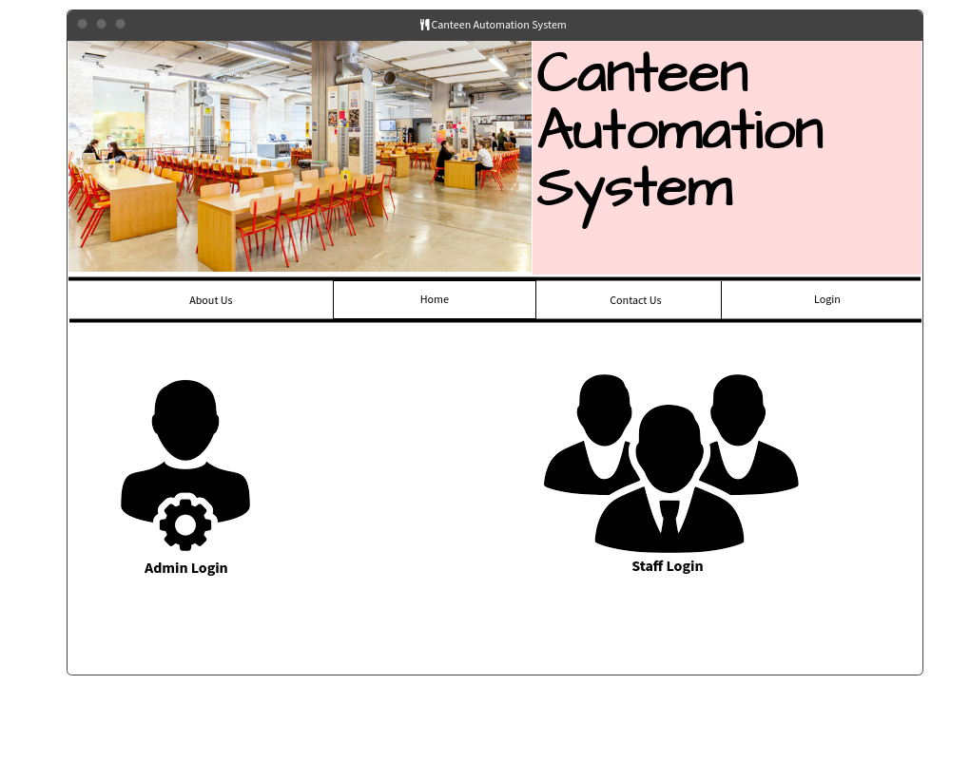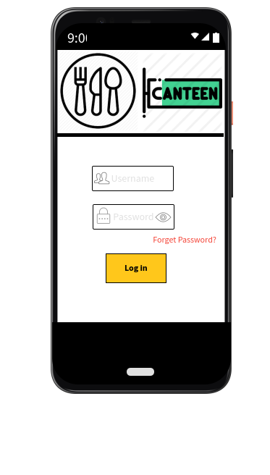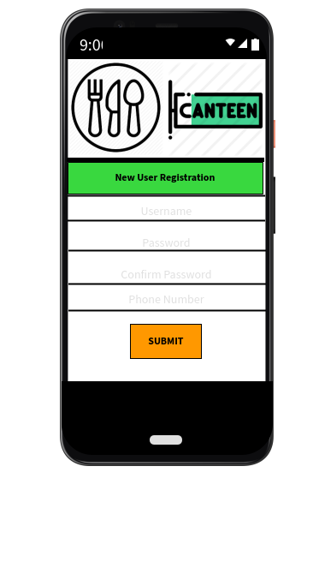

**4.5 Architecture:** we choose 3 tier architecture

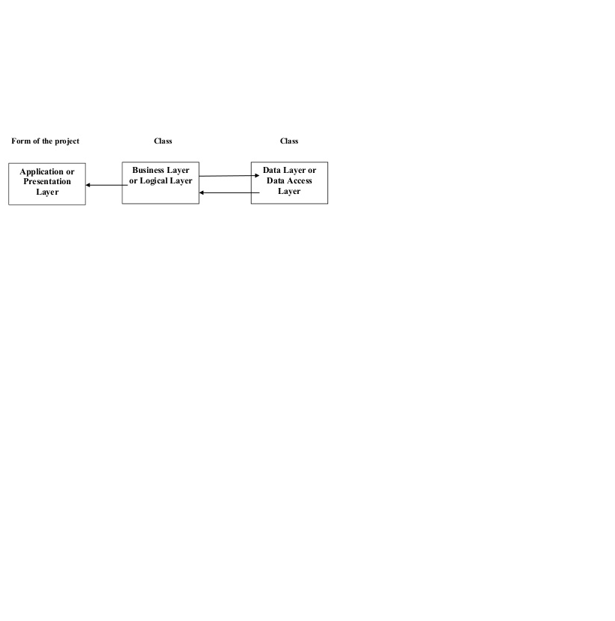

We choose it becuase it support the change mangement, so if anything happened such as increasing in the tax if we were using client server archticture rather than 3 tier archticture we will have to send an update to each client in the same time on a specific time, otherwise we may store wrong information. Also this categorization of the application makes the function more reusable easily and it becomes too easy to find the functions which have been written previously.

# 

# 5. IMPLEMENTATION

## 5.1 Tools, technologies and platforms used

Which tools, technologies, platforms, programming languages etc. did you use?

## 5.2 Algorithms

Give a high level description of the algorithms used for the main functions of the system. You may use pseudo-code.

## 5.3 Standards

What standards are applicable for the project? Which ones did you use? (e.g. standards for coding, designing components etc.)

## 5.4 Detailed description of the implementation (coding)

In this section, describe the system you have implemented in detail, with illustrative diagrams, tables, scenarios, etc. Give representative samples of the code you wrote, explaining how it works. Supplement the code with flow diagrams of modules, so that the context in which the code is used becomes obvious.

**THIS SECTION IS OPTINAL FOR CMSE 201 STUDENTS!**

# 6. TESTING

How did you test your system? What is your test data? What deficiencies/errors did the test results reveal? What corrections did you make as a result of deficiencies/errors discovered in the testing stage? How did you verify/validate the end product?

**THIS SECTION IS OPTINAL FOR CMSE 201 STUDENTS! YOU CAN WRITE YOUR TEST PLANS ONLY…**

# 7. USER GUIDE OF THE SYSTEM

Explain to the reader how the system should be used. In addition to verbal description, use screen shots if applicable, or any other illustrations as necessary.

**THIS SECTION IS OPTINAL FOR CMSE 201 STUDENTS!**

# 

# 8. DISCUSSION

Using this application is going to be like a response that people have waited for. Having food whenever you want is a privilege that everyone needs to have. The aim of takeout is to help this happen, to get food the way you want it, anytime you want it. Since the orders of the customers are in text that the restaurant can read while the order is being prepared, there is a substantial reduction in the chances of making a mistake while preparing a customer's order. This allows clients to be happy with restaurant food services, providing the restaurant with more sales. The application would allow people to save a lot of time; in the process of calling the restaurant over the phone, unnecessary time is wasted.

# 9. CONCLUSION

Our project primary goal is to save customers’ time and help and help them to have a productive day with no time wasting to go to the restaurant or canteen and order there, they can do it more easily by using this system. In this project we learned many things such as how we can design a diagram or a user interface and a lot of things.

# 10. REFERENCES

[1] IEEE. IEEE STD 830-1998 IEEE Recommended Practice for Software Requirements

Specifications. IEEE Computer Society, 1998.

[2] Automated Guide-Through Project Management Process. (n.d.). Retrieved January 11, 2021, from <https://www.visual-paradigm.com/>

[3] Cloud Prototyping for Product, UX and UI Design Teams. (n.d.). Retrieved January 11, 2021, from <https://atomic.io/>

[4] Free flowchart maker and diagrams online. (n.d.). Retrieved January 11, 2021, from <https://www.draw.io/>

[5] Free wireframe tools, prototyping tools (MockFlow). Retrieved January 11, 2021, from https://www.mockflow.com/